# ADDITIONS TO RSA IN MICROSOFT ADS FOR EXTENDED VERTICAL DYNAMIC REMARKETING BETA

New additions to RSAs signify you can customize campaigns around activities and searcher locations.



Today's trendy announcements follow suit. During this summertime, [Microsoft Advertising](https://about.ads.microsoft.com/en-us/blog/post/july-2021/dynamic-remarketing-expansion-other-july-product-updates?feed=blogposts) has been diving headfirst into developments that advantage advertisers in the retail, journey, automobile, and entertainment industries in the full-wave.

The beta for dynamic remarketing in Microsoft Advertising will now be multiplied past simply Retail (Hotels/Vacation Rentals), and could now be available for Automotive, Entertainment (occasions), and Travel (Tours and Activities). To gain access to this beta, advertisers will have to contact their account manager with Microsoft Advertising or contact support.

**Kevin Salat addressed-**

**“With Dynamic Remarketing, you can target audiences based on a specific product ID each user interacted with and show them an ad with that same product ID,”**

**More Updates:**

Along with the new industries delivered to Dynamic Remarketing, other announcements made with the aid of Microsoft Advertising encompass an updated UI to see how long a phase length is.

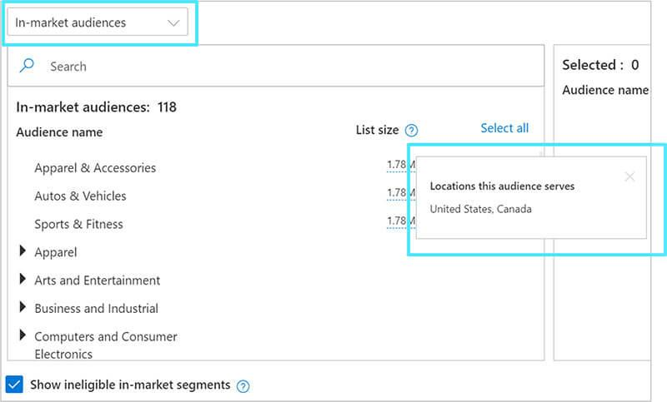

**Automated Bidding Changes:**

Along with this modification, advertisers can also rely on to look at automatic bidding (Maximize Conversions, Maximize Clicks, Target CPA, and Target ROAS) to turn to the Microsoft Audience Network. One caveat: “This is currently only for search campaigns extended to the native; standalone audience campaigns will be enabled for automated bidding in the coming months.”

**Free to consult, book a meeting with us:** [**https://www.w3era.com/contact-us/**](https://www.w3era.com/contact-us/)

**Additions To RSAs:**

Countdown customizers in RSAs mean you may now be capable of “dynamically insert countdowns into your RSAs to key moments in your business, like income or online activities.” And neighborhood insertions will help you add places to your RSAs to ensure that your searcher’s area is taken into account.

**Want to grow your business successfully?**

**Check out our service packages here:** [**https://www.w3era.com/**](https://www.w3era.com/)

**Reminders From Microsoft:**

Microsoft Advertising’s word fit and BMM changes are formally live for all advertisers globally. Plus, the business enterprise has deprecated the Intelligence Tool. Advertisers can now use the Keyword Planner tool.

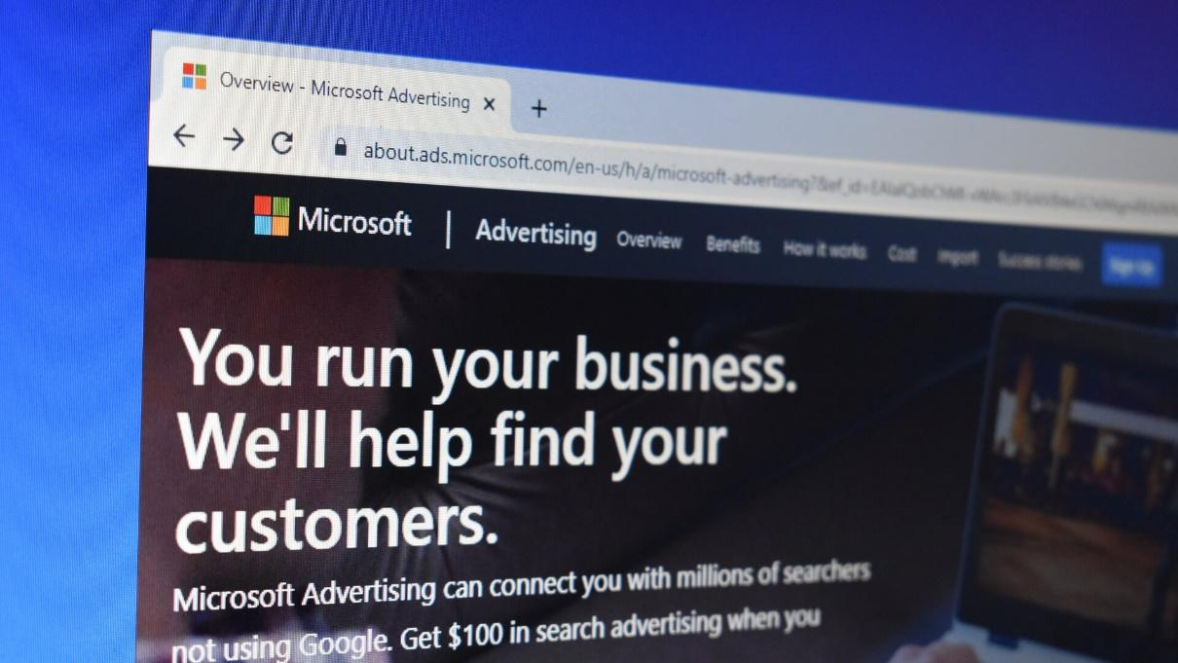

RSA is a [Responsive Search Ad](https://www.w3era.com/google-shopping-ads/) that conforms to shows more text and more relevant messages to your clients. By adapting your ad content to more nearly match potential client's search terms, responsive search ads may improve your campaign's performance. If you’re in the automotive, journey, or entertainment industry, you may want to talk to your AdWords rep about the Dynamic Remarketing beta and how to get started. The ability to install automatic bidding for the overall Microsoft Audience Network opens up more possibilities to reach a wider target audience of searchers whilst maximizing your spending. Plus, the brand new additions to RSAs suggest you can personalize campaigns around promptings and searcher places.



**Read more popular blogs here:**

<https://www.w3era.com/google-warns-users-while-having-unreliable-answer-on-trending-searches/>

<https://www.w3era.com/milestone-of-google-web-stories/>

<https://www.w3era.com/google-seller-rating-exhibit-for-organic-search/>

<https://www.w3era.com/40-ppc-tools-for-any-task/>

<https://www.w3era.com/instagram-no-longer-photo-sharing-app/>

**Vinita Choubisa**

**(Digital Marketing Executive)**